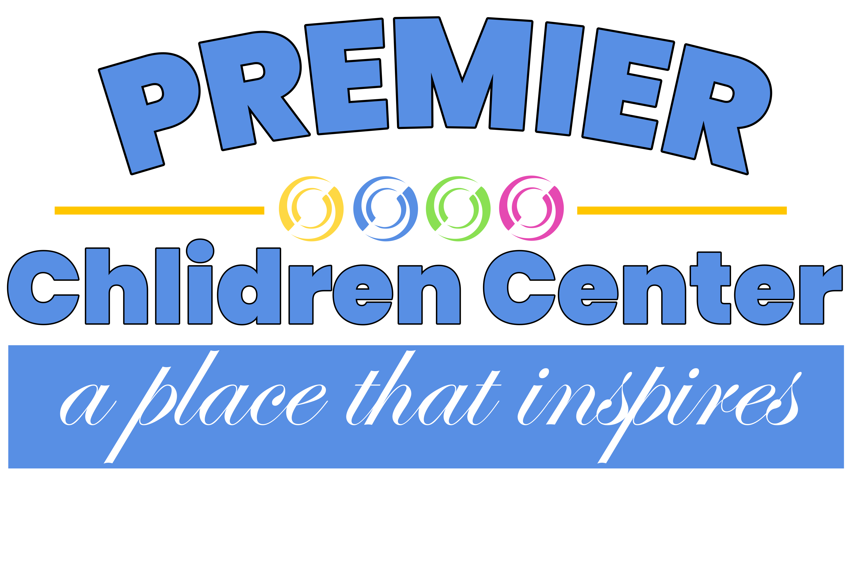
Premier Children Center
29721 6 Mile Rd. Livonia Mi 48152

Getting To Know Me!!

My name is: ___________________________________ My birthday is: _____________

My friends call me (nickname): _______________________________________________

I call the people I love: _______________________________________________________
(Child’s name for parents, family members, friends)

I live with: ___________________________________________________________________
(Mom, dad relative’s friends, pets)

My home languages(s) is/are: ________________________________________________

These words are important to know: __________________________________________
(Toileting words, comfort items, greetings)

My favorite foods are: _______________________________________________________

My meal times are: __________________________________________________________

Foods I never eat: ___________________________________________________________
(Due to allergy, sensitivity, religion, culture, etc.)

When falling asleep, I need: __________________________________________________
(Favorite blanket, special stuffed friend, milk, etc.)

These things scare me: ______________________________________________________

These things comfort me: ____________________________________________________

I don’t like: __________________________________________________________________

My favorite things: ___________________________________________________________
(Books, songs, things to do, places to go, etc.)

I am happiest when: __________________________________________________________

This year, my family hopes I will learn to: _____________________________________

______________________________________________________________________________

